**Final Project Report**

**Amin Alsultan**

**Nelson Harold Lawrence**

**CSC480**

**Date**: 5/8/2019

TABLE OF CONTENTS

|  |  |
| --- | --- |
| Abstract | 3 |
| Introduction | 3 |
| Literature Review | 4 |
| Design Methodology | 5 |
| Requirements | 5 |
| Use Cases | 6 |
| Physical System | 9 |
| User Interface | 9 |
| Database | 12 |
| Implementation | 15 |
| Tools | 15 |
| Programming Language | 16 |
| Coding | 16 |
| Testing | 18 |
| Completion Process | 18 |
| Conclusion & Future WORK | 19 |

**Abstract**

QUALITY Cars Seller is the project for the convenience of people to buy cars, van, trucks and other vehicles. AS this is the age of technology and technology is playing its role in almost every aspect of life but still, there are some gaps that we need to focus similarly there people face many problems while buying a vehicle and it is difficult to decide for an optimized option considering their all needs and preferring compensative in budget. This is why we have developed this system to reduce the conflicting situation and buying their best vehicle because we have a vast option for our customers to decide and select a suitable vehicle for them. Our system will help them to see all available categories and find the best option. Our system also provides a facility for searching according to their requirements and needs and able to get related results.

**Introduction**

The QUALITY Cars Seller is a project about vehicles retailing and shipping. The system is designed to accommodate all types of customers to understand the market and take the best decision for their vehicles. Our system reduces the cost of visiting markets and search for their desired thing and compromising on your one or more desires while buying because of less choice and option at the time of purchasing. Our system provides the old and new variety of vehicles according to the customer’s interest that they will love to buy so it makes a lot easy for them to choose best for them in one place.

Our project covers all types of vehicles that are famous and state of the art designs and modifications in vehicles are available for customers the system will show all varieties to customers but they can search according to their wish and desire. We can add or remove things from the database whenever we need to show more items we will add from the database and when one item will get sold we will delete that from the database. The interface for our system is very interactive that customer will see vehicle pictures, price, and benefits or properties of the vehicle. Customer needs to use our website because this project is web-based with a database of vehicles we will add and delete vehicles from the database for our customers. This project is all for the benefits of customers and to grow our business widely because many customers do not have time to come into the market and search for their desired item so they can use our website for this purpose and easily achieve their goal by saving their time and cost of visiting market.

**Literature review**

We have visited the market and research for customer’s needs and range. We have collected real-time scenarios and analyze them how people buy a vehicle and how they decide, compromise and choose the best item to buy. We have visited and taken help from the already developed system for this purpose and they don’t provide the efficient searching facility to customers that let them search according to their favorite brand model range and properties of vehicles so it is the major difference between those existing systems and our system.

**Design Methodology**

We have designed this system after a complete survey to provide our customers with the best solution for this problem at one platform. We have designed our system in PHP and SQL it is a web-based system that anyone can access it through the website and find items to buy. There is a SQL database to store our data for cars. We are adding and deleting data from the database when we need to do that.

**Requirements**

There are several functional requirements in our system

1. The system shall allow a user to see items on the web page.

2. The system shall allow the user to search items according to his desired parameters on the web page.

3. The system shall allow admin to add more items in the database.

4. The system shall allow admin to remove the item from the database.

5. The system shall allow the user to view search result on the next page when the user clicks on the search button.

6. The system shall allow the user to enter a brand name in input and show results for a search.

7. The system shall accessible to all users online as a website.

8. The system must be interactive that user can understand each action on his own.

9. The system must have a database to add data that will show on the website.

10. The system must have pictures for the item to facilitate customers.

There are few non-functional requirements also in our system it is only available on website only, and have constraint view for each customer he may able to see minimum 6 items on a page and user will see search result when he inputs the required fields that I will discuss further in brief design section.

**Use Cases**

There are only two use case scenarios for customer and admin will not have any interface he, she will add or remove data from database.

1. View item
2. Search item

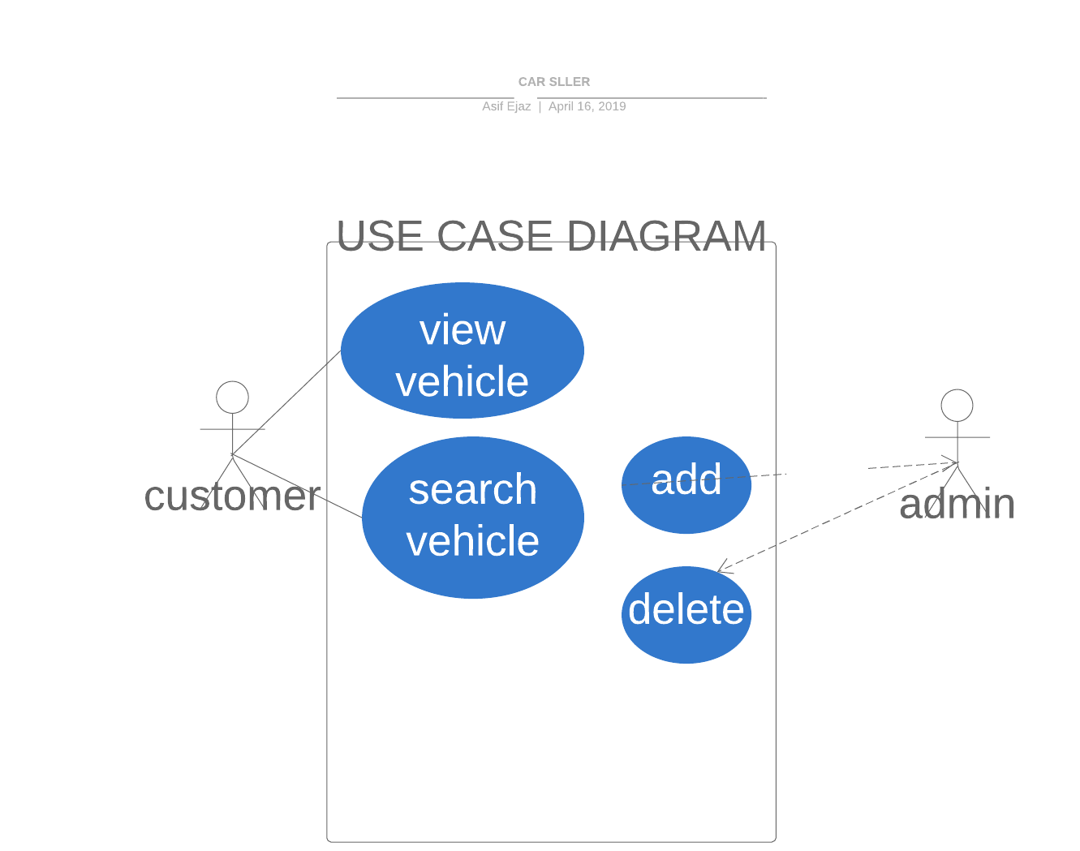

### **Customer’s Use Cases**

|  |  |  |  |
| --- | --- | --- | --- |
| View item | | | |
| **Actor:** custome**r** | | | |
| **Feature:** customer wants to view items on website. | | | |
| **Requirement ID** | | FR-01 | |
| **Use-Case ID** | | UC01 | |
| **Preconditions: no** | | | |
| **Scenarios** | | | |
| **Step #** | **User Action** | | **System Response** |
| 1. | Navigate to home screen using http:localhost/public/index.php | | System displays ‘index.php’ screen. |
|  | Click on any item | | System view items on this page |
| **Post Condition** | | | |
| System will show items to user on front page. | | | |
| **User Interface Reference** | | UI 1 | |

|  |  |  |  |
| --- | --- | --- | --- |
| View item | | | |
| **Actor:** custome**r** | | | |
| **Feature:** customer wants to search items on website. | | | |
| **Requirement ID** | | FR-02 | |
| **Use-Case ID** | | UC02 | |
| **Preconditions: no** | | | |
| **Scenarios** | | | |
| **Step #** | **User Action** | | **System Response** |
| 1. | Navigate to home screen using http:localhost/public/index.php | | System displays ‘index.php’ screen. |
|  | Input the required fields | | System will show input data in field |
|  | Click on search button | | System will show results for the search on next page |
| **Post Condition** | | | |
| System will show resulted items to user on next page. | | | |
| **User Interface Reference** | | UI 2 | |

**Physical System**

**Our system is working on any device that supports every browser like chrome, opera etc.it is a web-based system so the user must have internet connections to access the system. We use HTML, CSS, and PHP for the front interface for website and use SQL as a database for our system and the working system has above-mentioned functionalities.**

**User Interface**

**We have design user interface using HTML and CSS to make it interactive we have added pictures for every vehicle and size is enough that anyone can view its condition easily. The interface provides a view of vehicles to customers there are currently 6 vehicles on the front page. Here is the main page where customers are able to view all vehicles on screen.**

This page is showing vehical name pictue and price for the sake of conviente to our customers.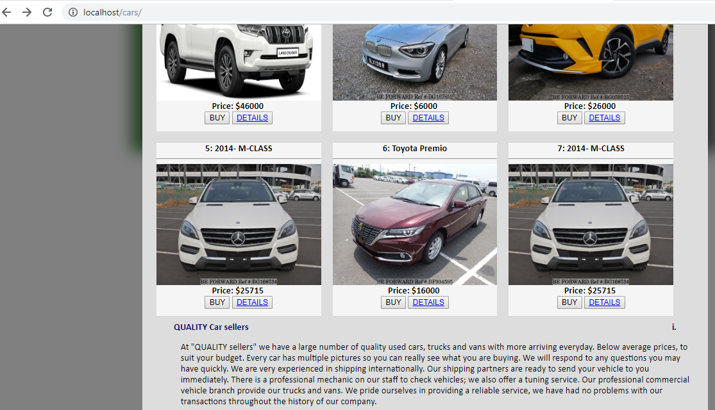

Searching functionality story boarding

The below page represents the searching function where customer inputs the required fields, and click on the search button.

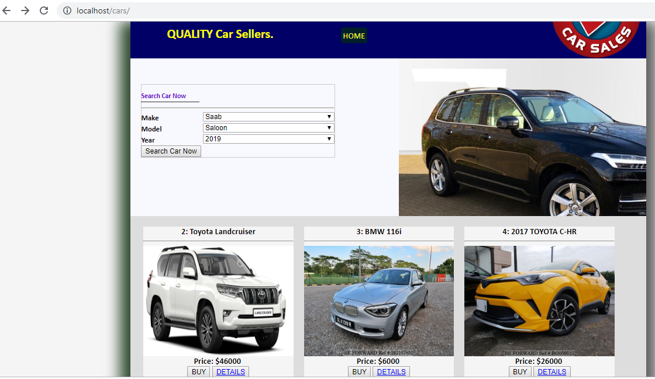

When he clicks on search button system will show the page below with searching results according to his searching query. At this moment we don’t have enough data in our database that can view as result.

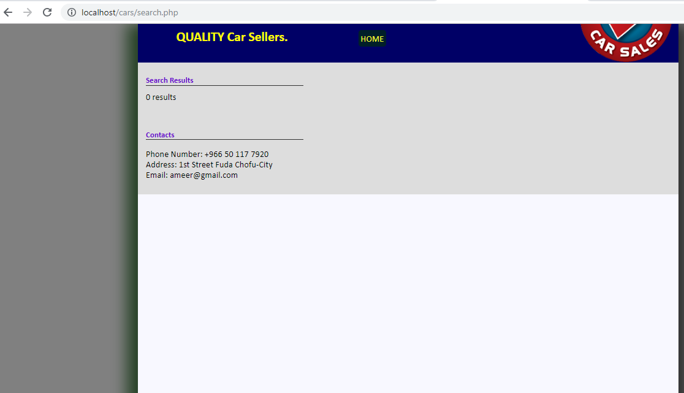

**Database**

Our system uses SQL database for storing vehicles data, and we have created table with specific fields to store our data in the correct format. Here is the illustration of our database table.

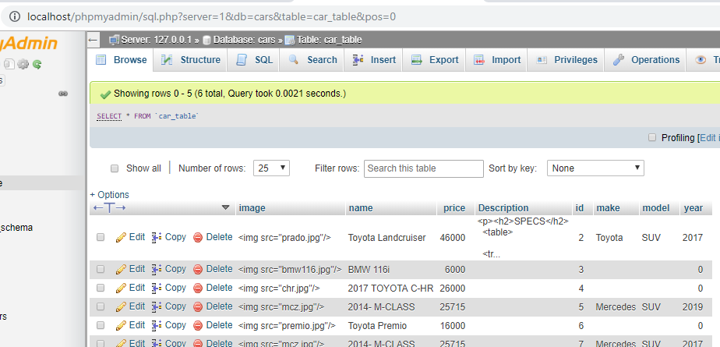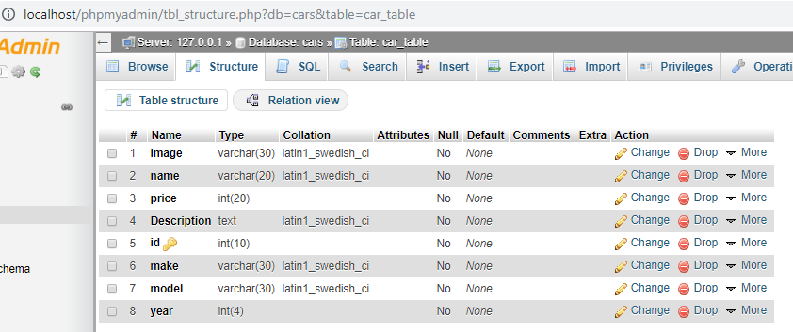

This table has several fields

ID: a primary key to uniquely identifying each record of a vehicle.

Image: this field is used to store image URL that will show image for vehicle on front view.

Price: this is a number type field to store price of vehicle in this table.

Description: this field used to store description about the vehicle.

Model: this is also a varchar field use to store model of the vehicle.

Year: this is used to store the year of vehicle.

Make: this field is used to store the manufacturers name in database.

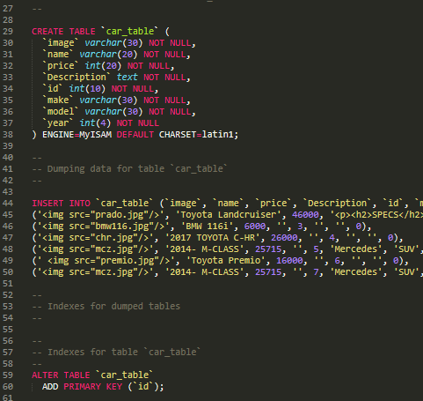

Interface between view and database

We use php as a backend language to fetch data from data base.

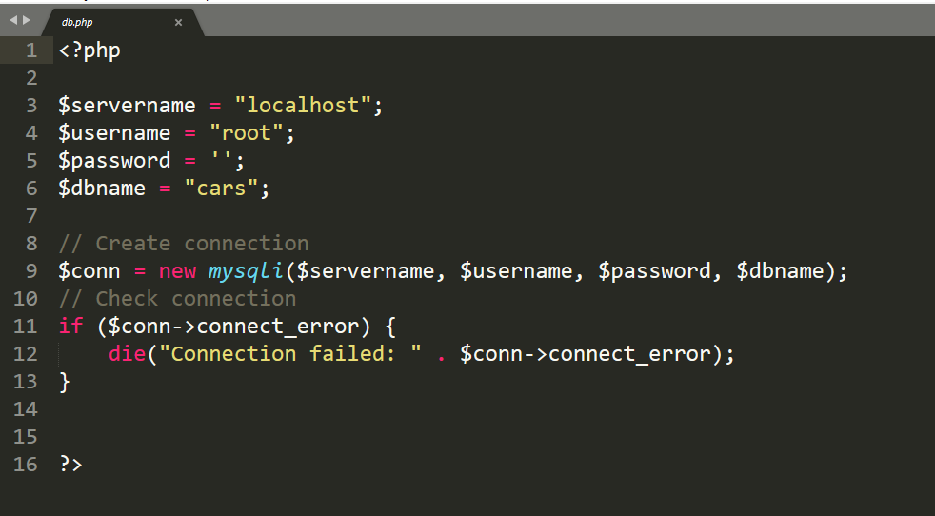

**Implementation**

For implementation I have used simple methodology the order of design phases is as follows

1. Get requirements
2. Requirement Analysis
3. Develop Use cases
4. Database design
5. Implement frontend + backend
6. Test

**Tools**

* I have used Sublime text editor for coding.
* LAMP software for database design and management
* Chrome browser for encoding of code and presenting website.

**Programing languages**

1. I have used HTMLCSS for frontend interface
2. I have used PHP for backend purpose
3. I have used SQL for database programming

**Coding** 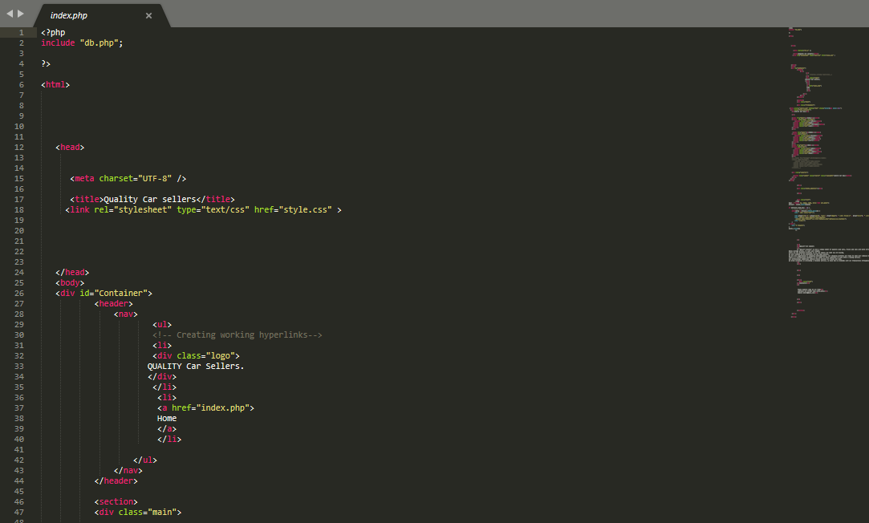

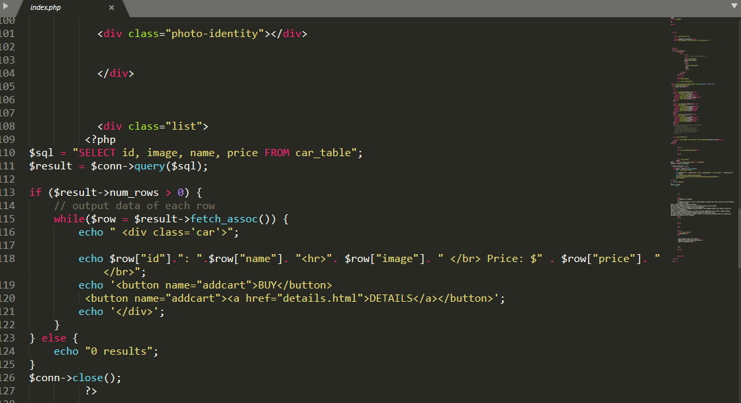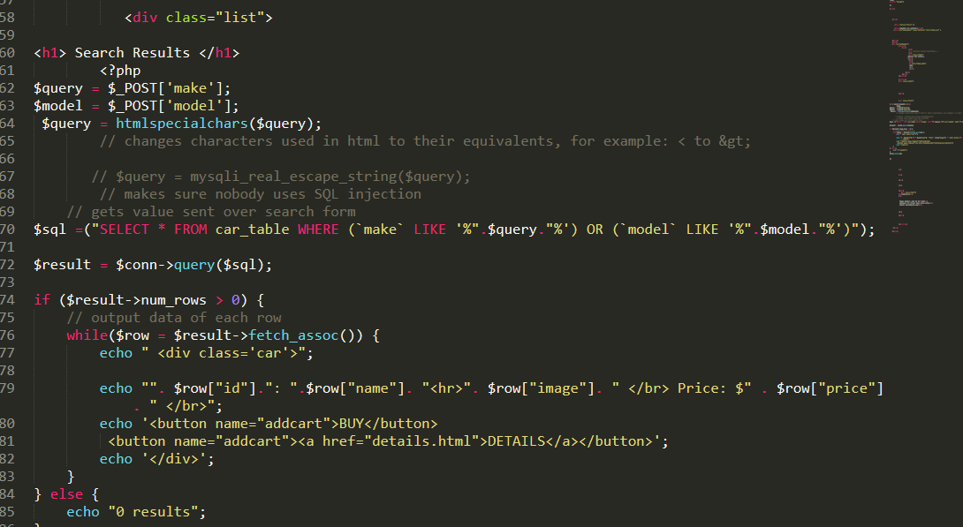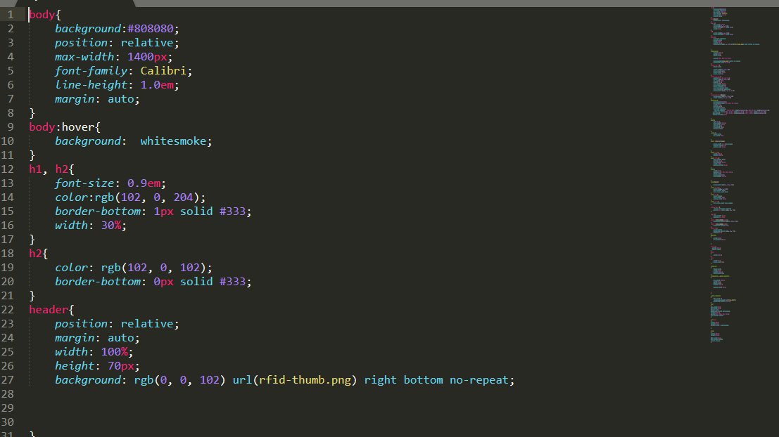

**Testing**

I have used black box testing and test working of my system explicitly and I concluded that each and every function is working fine.

**Completion Process**

I work day by day according to work break down structure for this project as follows

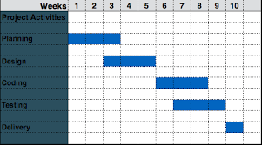

Conclusion and Future Work

This project is all about facilitating our customers to buy their best item by making the best decisions through our system. Our system completely fulfills the customer’s needs as it has a well-organized interface that everyone will easily use and find a search function for their choice. This system is completely according to the customer’s interest and provides benefits of decision making at their home. So, we meet our goal and expectations quiet efficiently and want to add more and more content in the database for our customers. And we want to have some extensions also to provide more benefits to our customers like online booking for vehicles.

This system needs more and more data to view customers and for the searching facility if we have more content related to that search it will be more effective for our customers. This system can be extended for online booking of their desired item to avoid conflicts of interest in between two customers. We have learned a lot from this project and improve our knowledge related to implementations for such type of projects. We use typical software development lifecycle by gathering requirements then design a system. During implementation, we face some problems in requirements. So, it is most important to have a clear cut and specific requirement details to implement a system perfectly. We will next time take extra care for requirements gathering and analysis in order to make the project successful and to fulfill customers and clients desires.